**Project Design Phase-II**

**Technology Stack (Architecture & Stack)**

|  |  |
| --- | --- |
| Date | 03 October 2022 |
| Team ID | PNT2022TMIDxxxxxx |
| Project Name | Project - |
| Maximum Marks | 4 Marks |

**Technical Architecture:**

The Deliverable shall include the architectural diagram as below and the information as per the table1 & table 2

Guidelines:

1. Include all the processes (As an application logic / Technology Block)
2. Provide infrastructural demarcation (Local / Cloud)
3. Indicate external interfaces (third party API’s etc.)
4. Indicate Data Storage components / services
5. Indicate interface to machine learning models (if applicable)

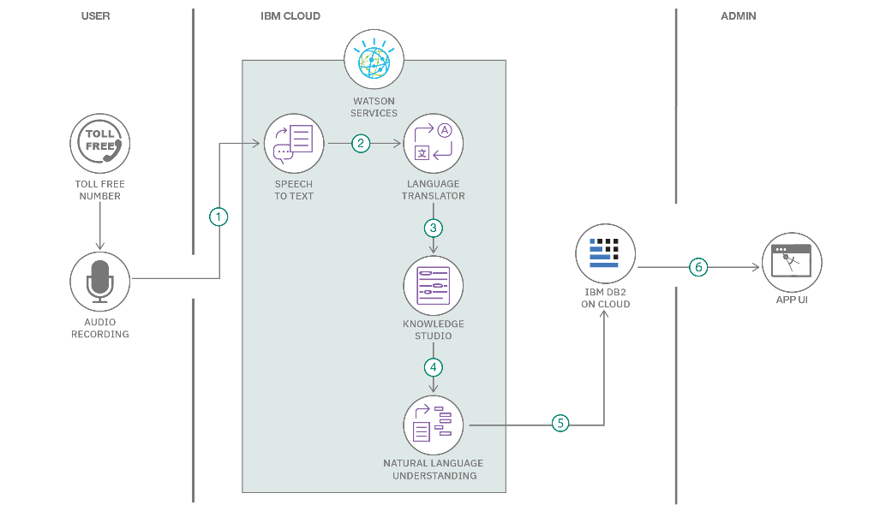

**Table-1 : Components & Technologies:**

|  |  |  |  |
| --- | --- | --- | --- |
| **S.No** | **Component** | **Description** | **Technology** |
|  | User Interface | How user interacts with application e.g.  Web UI, Mobile App, Chatbot etc. | Python |
|  | Application Logic-1 | Logic for a process in the application | Python |
|  | Application Logic-2 | Logic for a process in the application | IBM Watson STT service |
|  | Application Logic-3 | Logic for a process in the application | IBM Watson Assistant |
|  | Database | Data Type, Configurations etc. | Python |
|  | Cloud Database | Database Service on Cloud | IBM Cloudant. |
|  | File Storage | File storage requirements | IBM Block Storage or Other Storage Service or Local Filesystem |
|  | External API-1 | Purpose of External API used in the application | Medicine intake Reminder |
|  | Machine Learning Model | Purpose of Machine Learning Model | Personal assistant |
|  | Infrastructure (Server / Cloud) | Application Deployment on Local System / Cloud  Local Server Configuration:  Cloud Server Configuration : | Local, Cloud Foundry etc. |

**Table-2: Application Characteristics:**

| **S.No** | **Characteristics** | **Description** | **Technology** |
| --- | --- | --- | --- |
|  | Open-Source Frameworks | List the open-source frameworks used | Python IDLE |
|  | Security Implementations | List all the security / access controls implemented, use of firewalls etc. | e.g. SHA-256, Encryptions, IAM Controls, OWASP etc. |
|  | Scalable Architecture | Justify the scalability of architecture (3 – tier, Micro-services) | 3 tier architecture is used .Each process is independent |
|  | Availability | Justify the availability of application (e.g. use of load balancers, distributed servers etc.) | Technology used here is load balancers. Load balancer serves as the single point of contact for clients. |
|  | Performance | Design consideration for the performance of the application (number of requests per sec, use of Cache, use of CDN’s) etc. | CDN is used to avoid network traffic and the request depends on the user. |

**References:**

**[https://www.google.com/url?sa=t&rct=j&q=&esrc=s&source=web&cd=&cad=rja&uact=8&ved=2ahUKEwjIivTohJL7AhX7bGwGHU96C5cQFn](https://www.google.com/url?sa=t&rct=j&q=&esrc=s&source=web&cd=&cad=rja&uact=8&ved=2ahUKEwjIivTohJL7AhX7bGwGHU96C5cQFnoECC4QAQ&url=https%3A%2F%2Fwww.iotforall.com%2Fiot-solutions-that-improve-senior-care&usg=AOvVaw1l3y_5r5GromoVaDZhrn9q)**

[**https://www.google.com/url?sa=t&rct=j&q=&esrc=s&source=web&cd=internet-of-things%2Felderly-independent-smart-home%2F&usg=AOvVaw0SHVU5TVqfvMJ4_G53Sjob**](https://www.google.com/url?sa=t&rct=j&q=&esrc=s&source=web&cd=&cad=rja&uact=8&ved=2ahUKEwjIivTohJL7AhX7bGwGHU96C5cQFnoECDEQAQ&url=https%3A%2F%2Fwww.ibm.com%2Fblogs%2Finternet-of-things%2Felderly-independent-smart-home%2F&usg=AOvVaw0SHVU5TVqfvMJ4_G53Sjob)

[**https://www.ijcna.org/Manuscripts/IJCNA-2017-O-08.pdf**](https://www.ijcna.org/Manuscripts/IJCNA-2017-O-08.pdf)

[**https://www.google.com/url?sa=in%2F&usg=AOvVaPncQMgonB**](https://www.google.com/url?sa=t&rct=j&q=&esrc=s&source=web&cd=&cad=rja&uact=8&ved=2ahUKEwjQwJrEhJL7AhWyTGwGHfFcDJUQFnoECAIQAQ&url=https%3A%2F%2Fhelpdeskgeek.com%2Fnetworking%2Fwhat-is-a-cdn-why-is-one-essential-if-you-own-a-domain%2F&usg=AOvVaw0bgdnrrFw8O6YPncQMgonB)